Test Case: tc002_SPX_Dev5_Crear_Requisicion_Spot_Con_FAD_Tipo_Cobro_CC
Step 1 - Enter username and password and click to button Enter : Credentials Entered
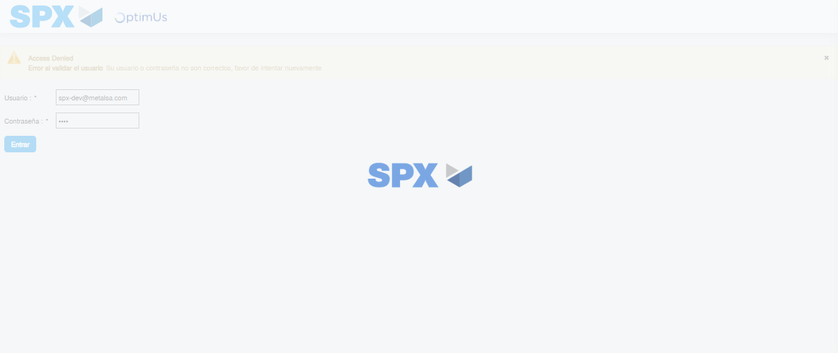Image file-name: QC_Testing-tc002_SPX_Dev5_Crear_Requisicion_Spot_Con_FAD_Tipo_Cobro_CC-1785960719987

Step 2 - Select to UEN and Access to Spot Buy Requisitions : UEN Correctly selected and Correct access
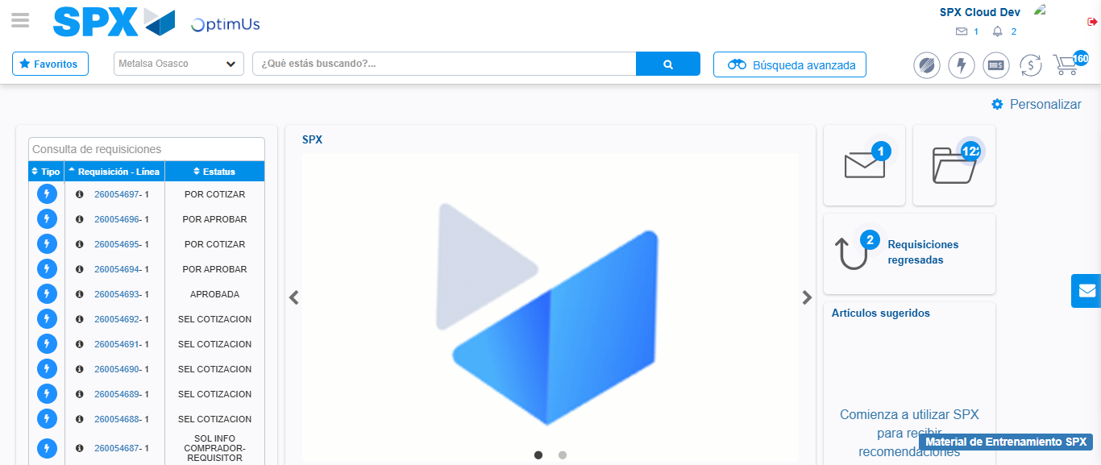Image file-name: QC_Testing-tc002_SPX_Dev5_Crear_Requisicion_Spot_Con_FAD_Tipo_Cobro_CC-1785960744559

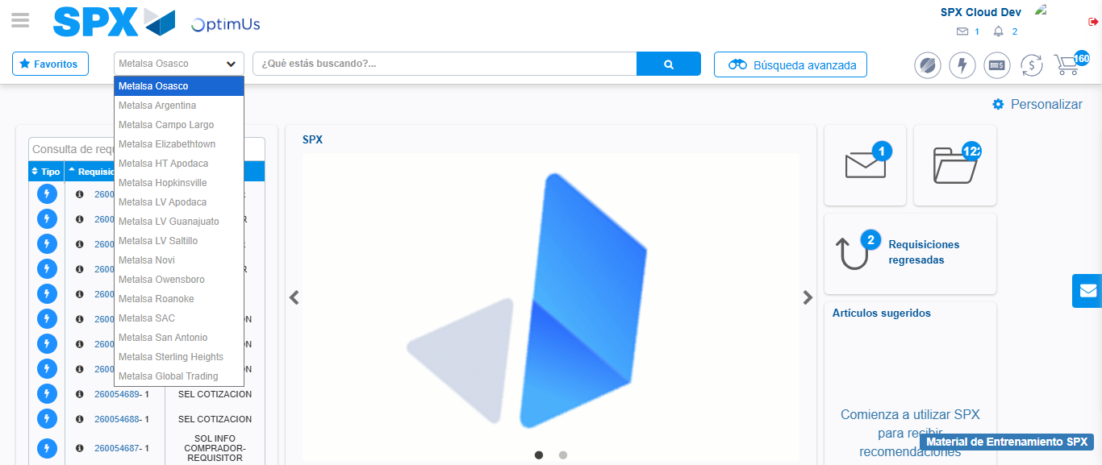Image file-name: QC_Testing-tc002_SPX_Dev5_Crear_Requisicion_Spot_Con_FAD_Tipo_Cobro_CC-1785960747155

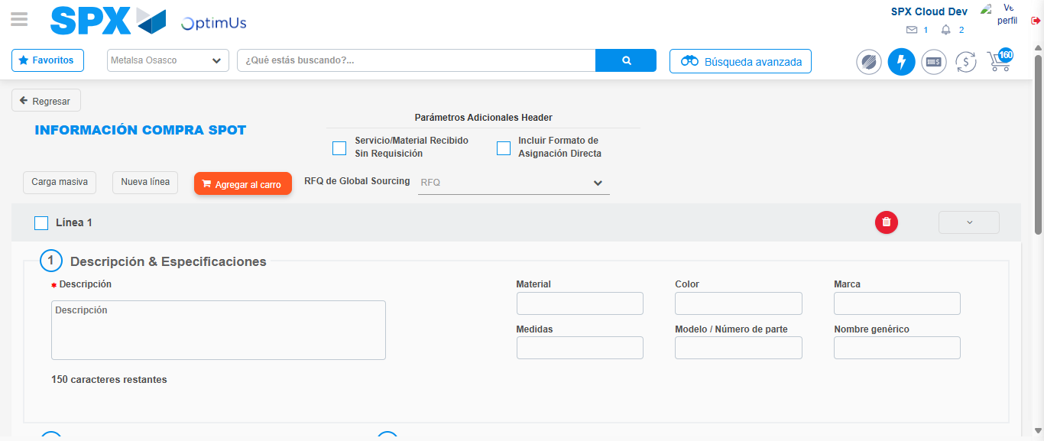Image file-name: QC_Testing-tc002_SPX_Dev5_Crear_Requisicion_Spot_Con_FAD_Tipo_Cobro_CC-1785960754027

Step 3 - Add FAD to Requisition: FAD Successfully Added
Image file-name: QC_Testing-tc002_SPX_Dev5_Crear_Requisicion_Spot_Con_FAD_Tipo_Cobro_CC-1785960754264

Image file-name: QC_Testing-tc002_SPX_Dev5_Crear_Requisicion_Spot_Con_FAD_Tipo_Cobro_CC-1785960754429

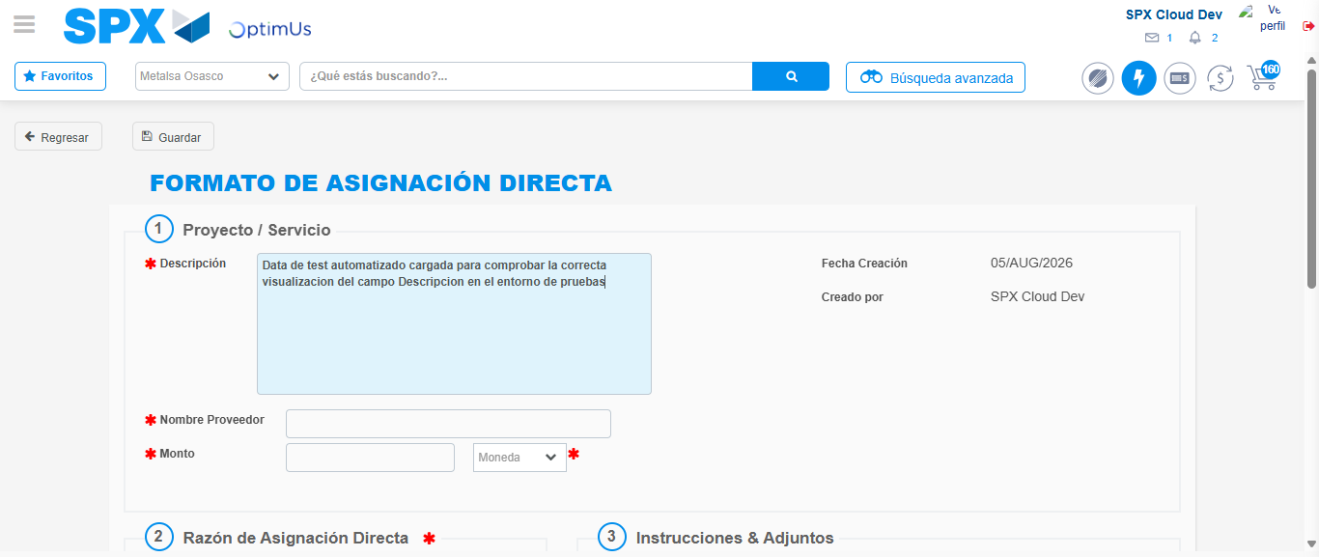Image file-name: QC_Testing-tc002_SPX_Dev5_Crear_Requisicion_Spot_Con_FAD_Tipo_Cobro_CC-1785960757098

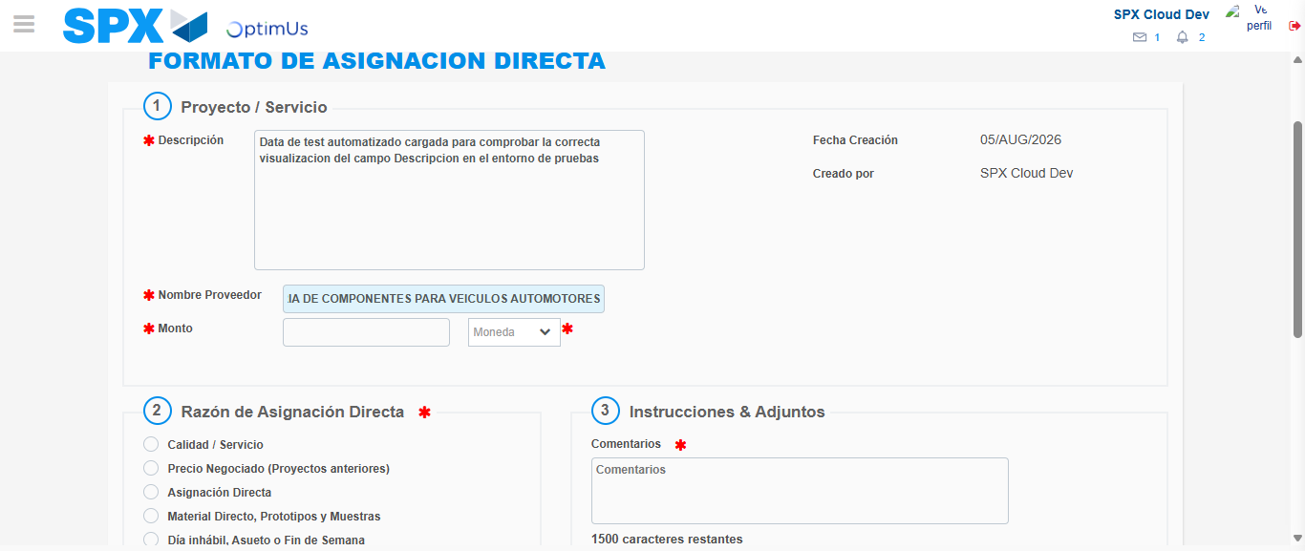Image file-name: QC_Testing-tc002_SPX_Dev5_Crear_Requisicion_Spot_Con_FAD_Tipo_Cobro_CC-1785960766257

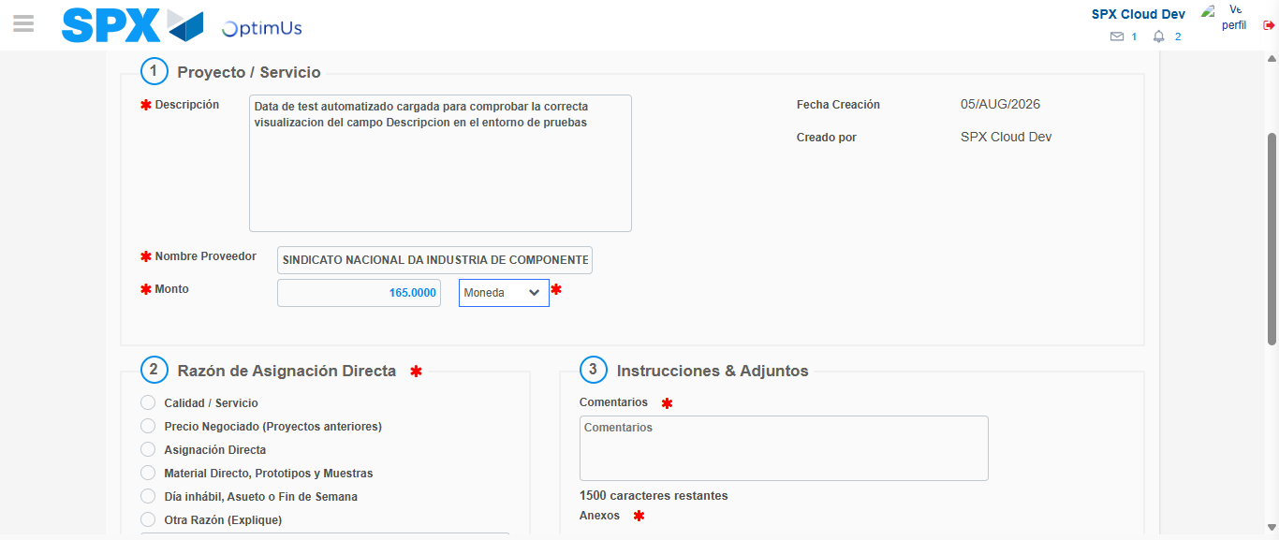Image file-name: QC_Testing-tc002_SPX_Dev5_Crear_Requisicion_Spot_Con_FAD_Tipo_Cobro_CC-1785960766655

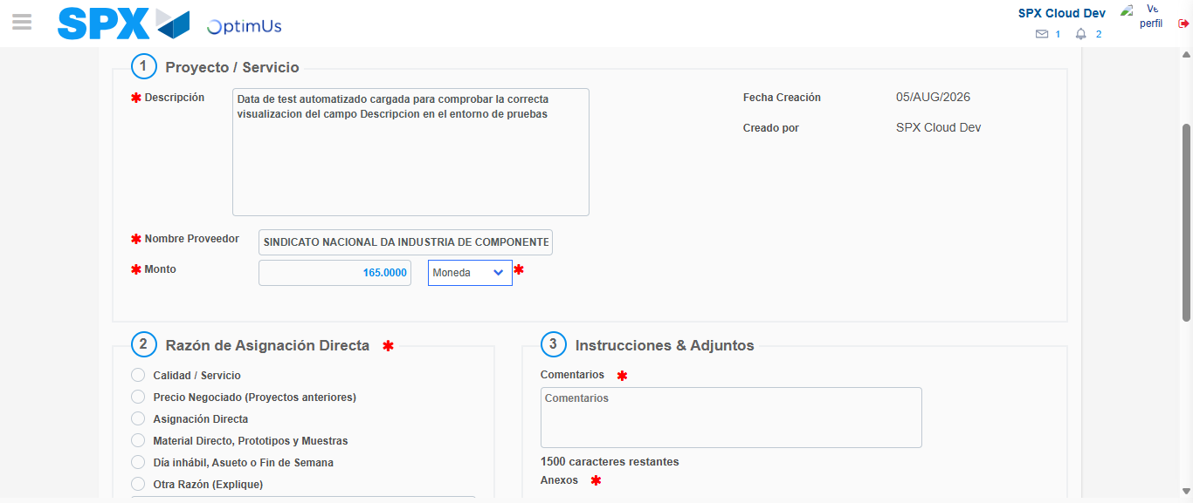Image file-name: QC_Testing-tc002_SPX_Dev5_Crear_Requisicion_Spot_Con_FAD_Tipo_Cobro_CC-1785960766860

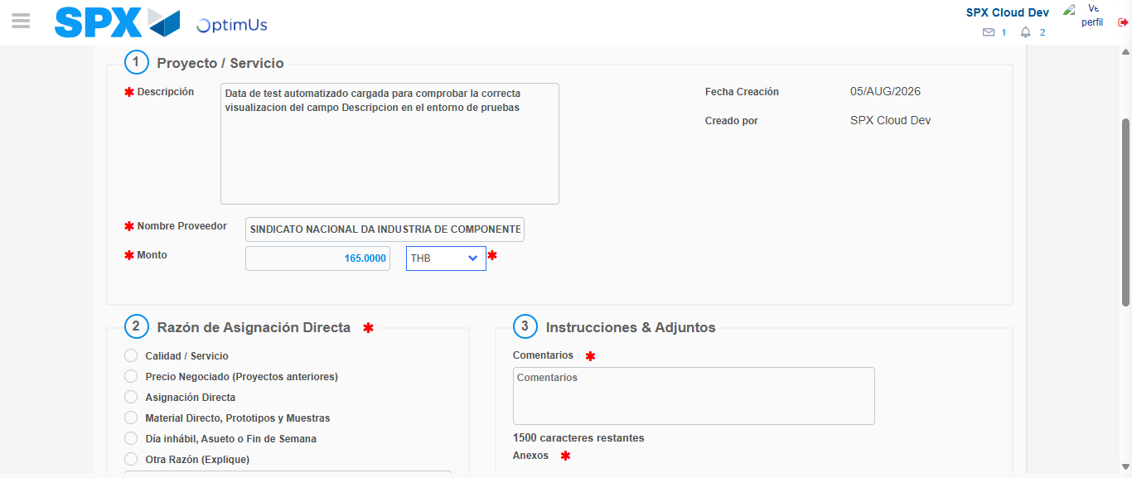Image file-name: QC_Testing-tc002_SPX_Dev5_Crear_Requisicion_Spot_Con_FAD_Tipo_Cobro_CC-1785960767218

Image file-name: QC_Testing-tc002_SPX_Dev5_Crear_Requisicion_Spot_Con_FAD_Tipo_Cobro_CC-1785960767380

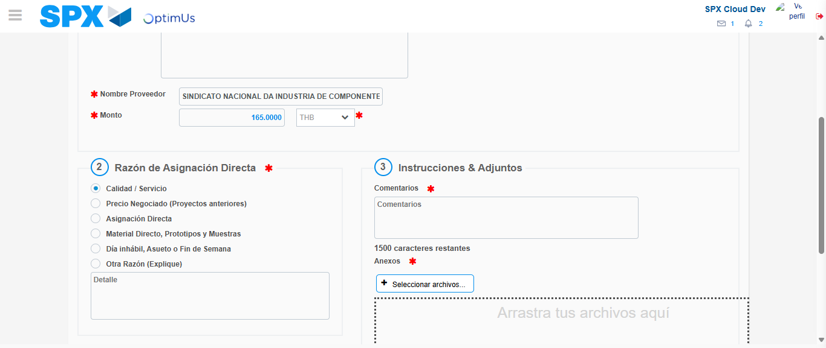Image file-name: QC_Testing-tc002_SPX_Dev5_Crear_Requisicion_Spot_Con_FAD_Tipo_Cobro_CC-1785960768213

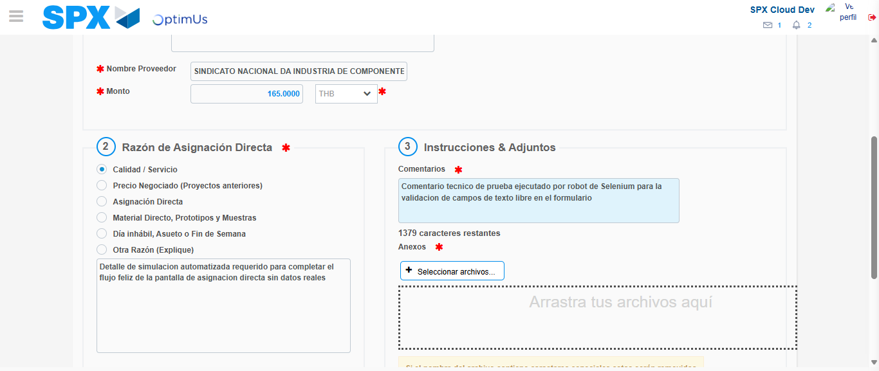Image file-name: QC_Testing-tc002_SPX_Dev5_Crear_Requisicion_Spot_Con_FAD_Tipo_Cobro_CC-1785960779183

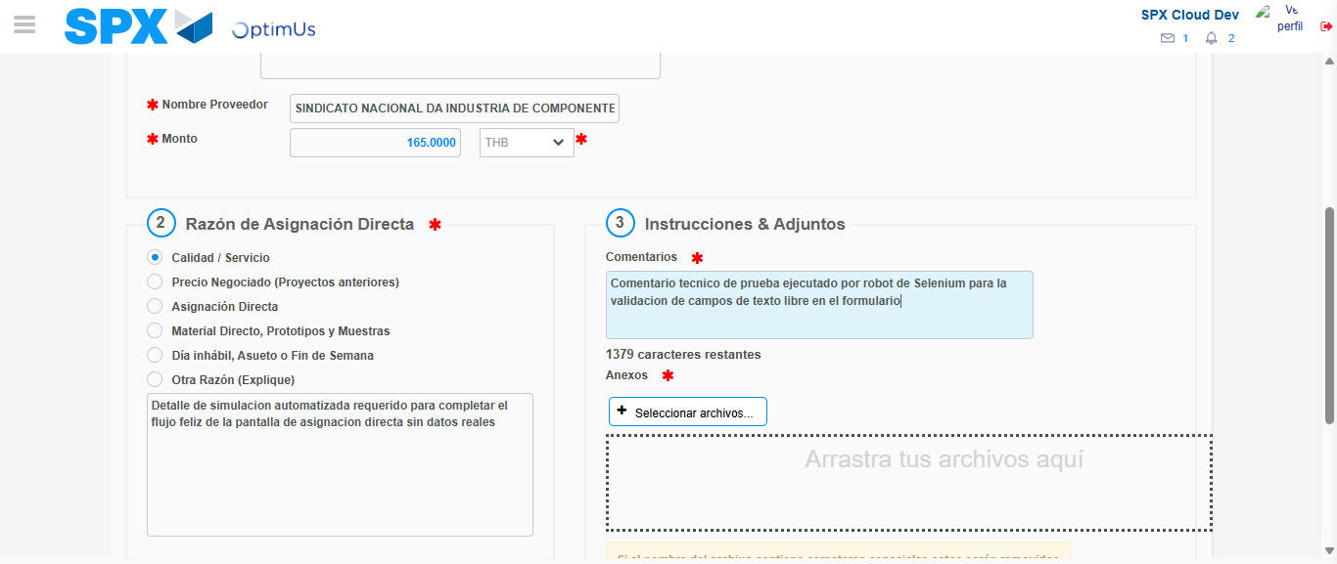Image file-name: QC_Testing-tc002_SPX_Dev5_Crear_Requisicion_Spot_Con_FAD_Tipo_Cobro_CC-1785960779829

Step 4 - Data Capture Spot Buy Requisition: Data captured correctly
Image file-name: QC_Testing-tc002_SPX_Dev5_Crear_Requisicion_Spot_Con_FAD_Tipo_Cobro_CC-1785960754264

Image file-name: QC_Testing-tc002_SPX_Dev5_Crear_Requisicion_Spot_Con_FAD_Tipo_Cobro_CC-1785960754429

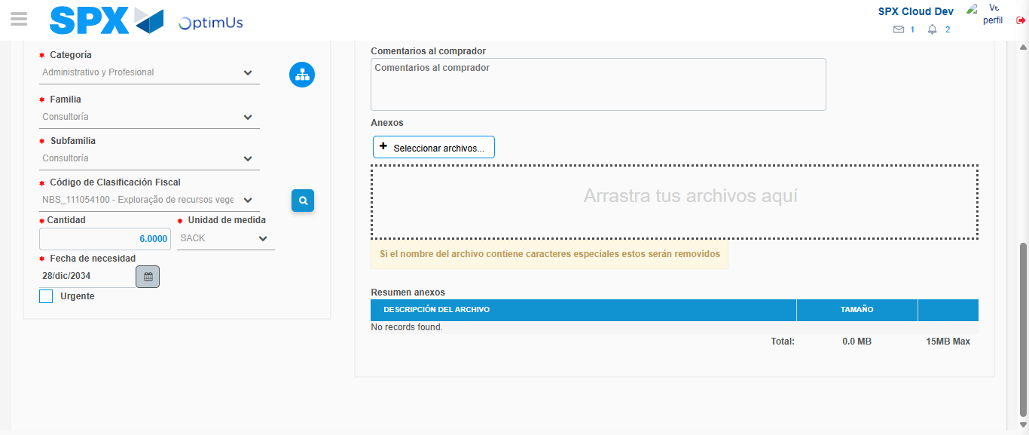Image file-name: QC_Testing-tc002_SPX_Dev5_Crear_Requisicion_Spot_Con_FAD_Tipo_Cobro_CC-1785960796139

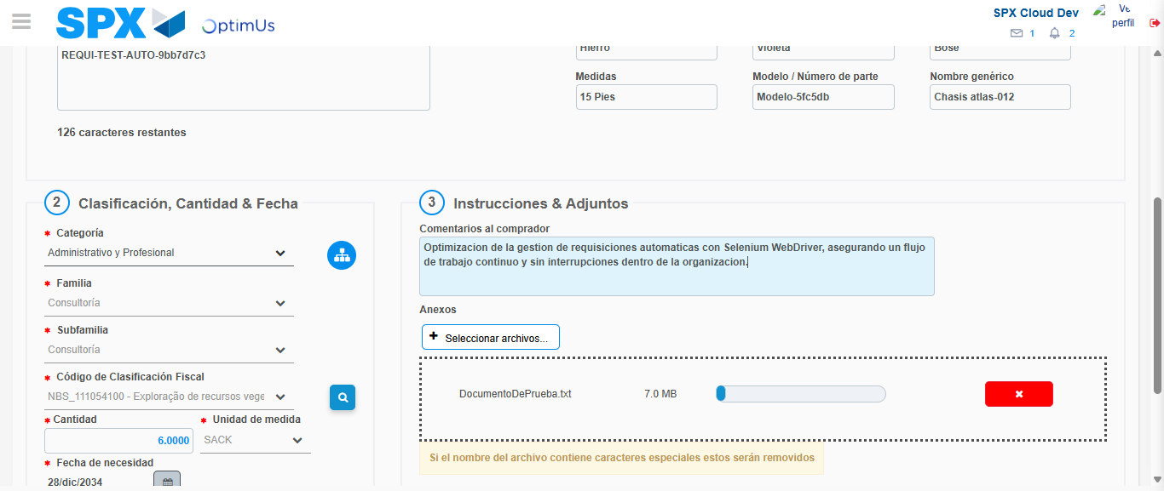Image file-name: QC_Testing-tc002_SPX_Dev5_Crear_Requisicion_Spot_Con_FAD_Tipo_Cobro_CC-1785960796881

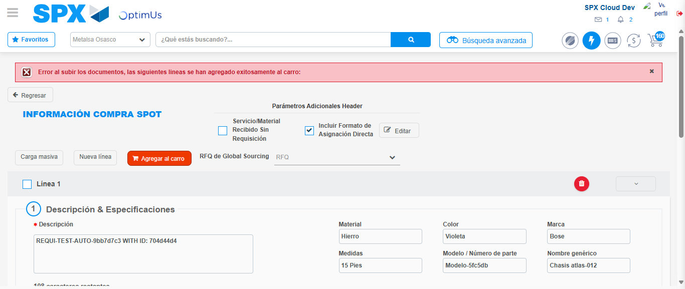Image file-name: QC_Testing-tc002_SPX_Dev5_Crear_Requisicion_Spot_Con_FAD_Tipo_Cobro_CC-1785960807374

Step 8 - Return to Main Page SPX : Return to Main Page SPX
Image file-name: QC_Testing-tc002_SPX_Dev5_Crear_Requisicion_Spot_Con_FAD_Tipo_Cobro_CC-1785960744559

Image file-name: QC_Testing-tc002_SPX_Dev5_Crear_Requisicion_Spot_Con_FAD_Tipo_Cobro_CC-1785960747155

Image file-name: QC_Testing-tc002_SPX_Dev5_Crear_Requisicion_Spot_Con_FAD_Tipo_Cobro_CC-1785960754027

Image file-name: QC_Testing-tc002_SPX_Dev5_Crear_Requisicion_Spot_Con_FAD_Tipo_Cobro_CC-1785960809609

Image file-name: QC_Testing-tc002_SPX_Dev5_Crear_Requisicion_Spot_Con_FAD_Tipo_Cobro_CC-1785960809761

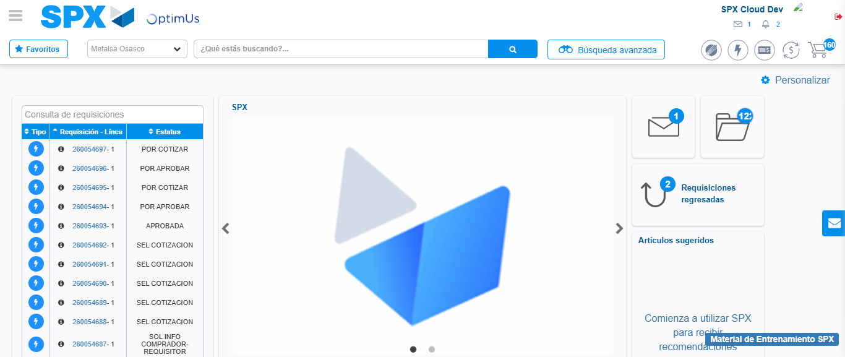Image file-name: QC_Testing-tc002_SPX_Dev5_Crear_Requisicion_Spot_Con_FAD_Tipo_Cobro_CC-1785960830751

Step 9 - Log Out : Log Out SPX
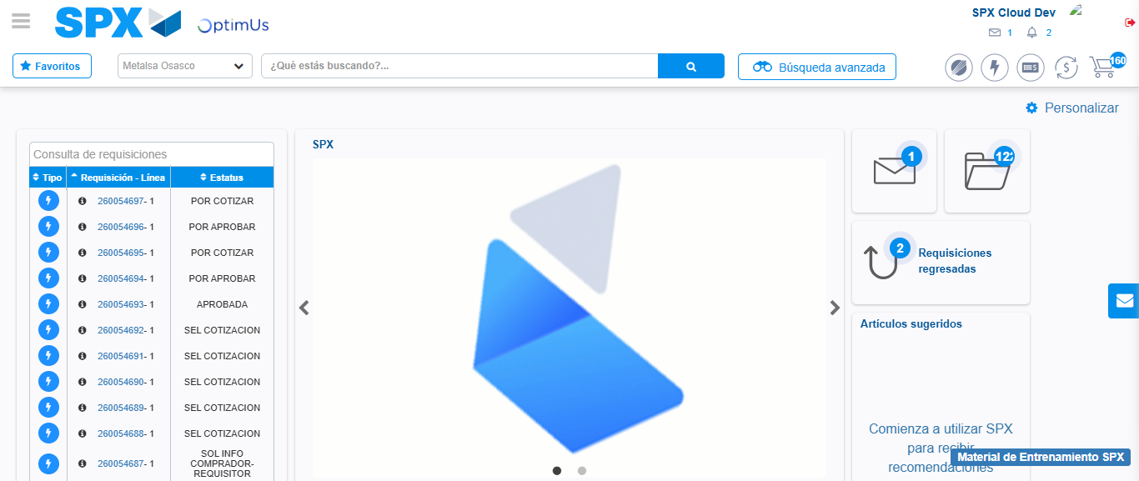Image file-name: QC_Testing-tc002_SPX_Dev5_Crear_Requisicion_Spot_Con_FAD_Tipo_Cobro_CC-1785960831050

